Jordan Bankston

October 12, 2025

Southern New Hampshire University

Professor Liwanag

# Purpose of the CRUD Python Module

This module encapsulates Create, Read, Update, and Delete operations for the Austin Animal Center (AAC) 'animals' collection. It centralizes connection handling, optionally supports authentication, validates inputs, and returns clear results (boolean for creates, list for reads, counts for updates/deletes) so client code can reuse it across a dashboard or future services.

# How to Use the Module

1) Import AAC CSV into MongoDB

mongoimport --type=csv --headerline --db aac --collection animals --drop ./datasets/aac_shelter_outcomes.csv

2) (If required) Create an authenticated user in mongosh

use aac  
db.createUser({  
 user: "aacuser",  
 pwd: "Mila",  
 roles: [ { role: "readWrite", db: "aac" } ]  
})

3) Instantiate and call methods from Python:

from CRUD_Python_Module import AnimalShelter

db = AnimalShelter() # no creds

db.create({"name":"Sinclaire","species":"Dog"})

print(db.read({"species":"Dog"}))

print(db.update({"name":"Sinclaire"},{"age":4}))

print(db.delete({"name":"Sinclaire"}))

# Why PyMongo Driver

PyMongo is the official MongoDB driver for Python with robust collection operations (find, insert_one, update_one/update_many, delete_one/delete_many), cursor support, and clear exceptions—ideal for a reusable CRUD module.

# Attributes and Working Functionality

__init__(username=None, password=None, host='localhost', port=27017, db_name='aac', coll_name='animals', auth_db=None):  
 Creates a MongoClient, pings the server, selects the database/collection.  
create(data: dict) -> bool:  
 Inserts one document; True if acknowledged.  
read(query: dict) -> list:  
 Returns a list of matching documents using find().  
update(query: dict, new_values: dict, many: bool=False) -> int:  
 Returns number of modified documents.  
delete(query: dict, many: bool=False) -> int:  
 Returns number of deleted documents.

# Demonstration – Insert Screenshots Here

• Screenshot 1: CSV import execution (mongoimport).

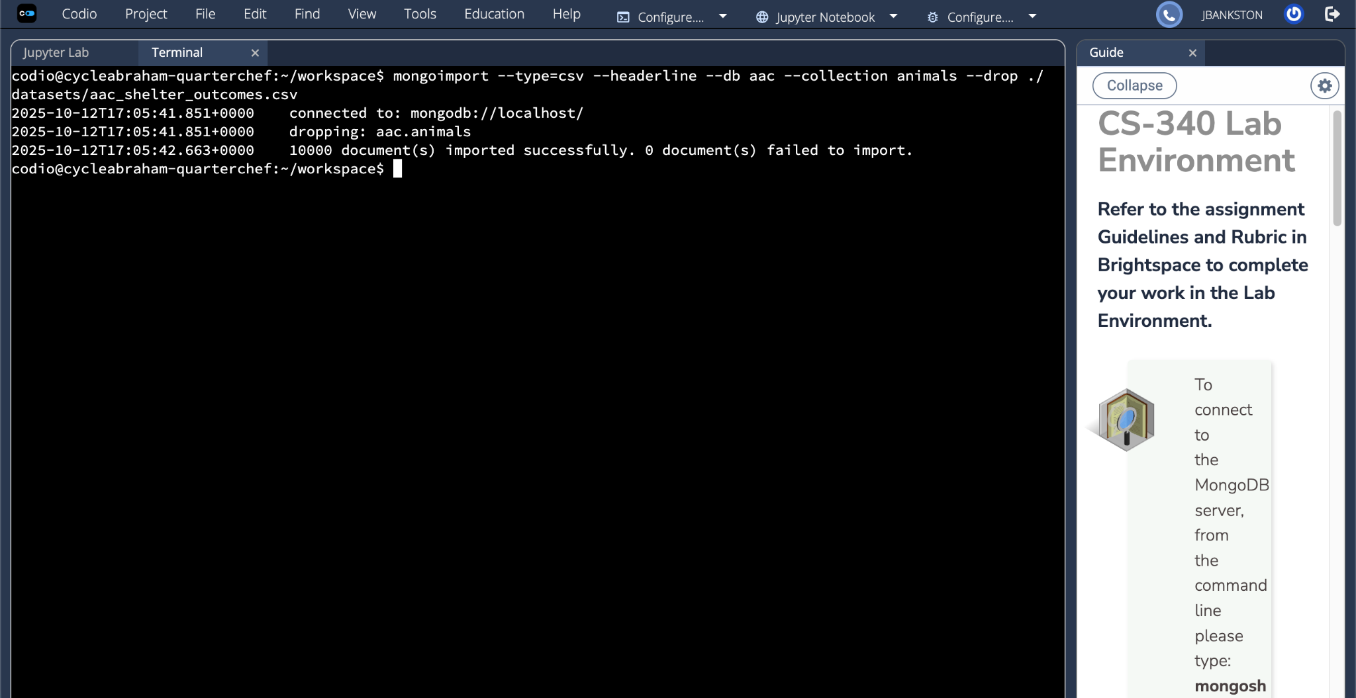

• Screenshot 2: Mongo authentication (login as aacuser).

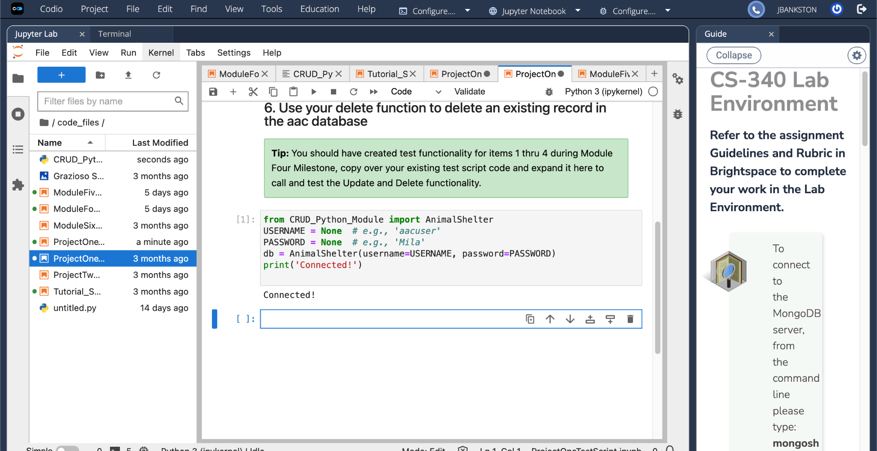

• Screenshot 3: Jupyter results for Create/Read/Update/Delete from ProjectOneTestScript.

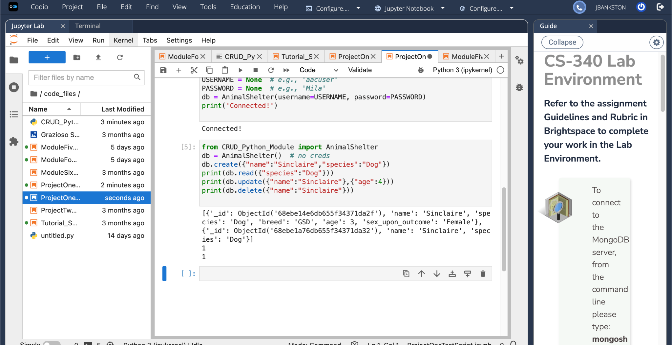

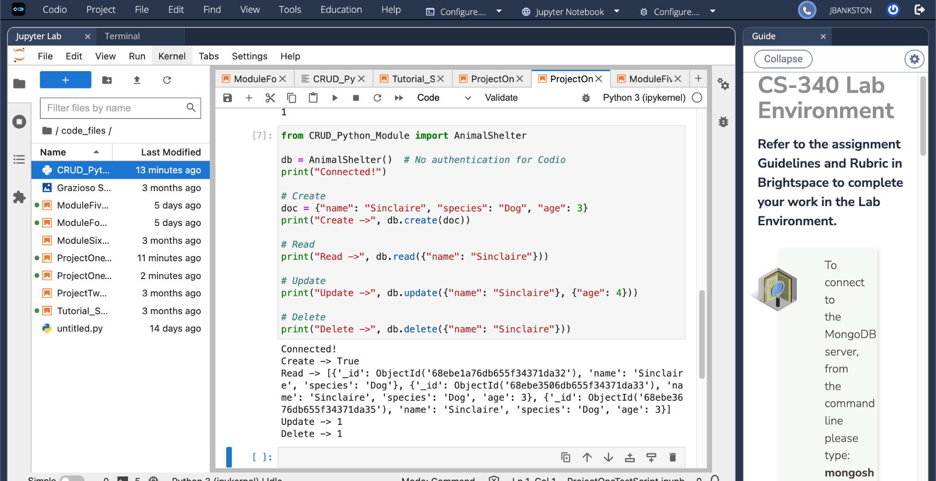

# Troubleshooting

If you see ServerSelectionTimeoutError, start MongoDB and verify host/port/auth. Example checks: `sudo service mongod status`, `mongosh --eval 'db.runCommand({ping:1})'`, and confirm credentials/roles.